FCYSL 2022 Socctoberfest

October 28-30, 2022 Acceptance Package

TEAMS WITHIN 1 HOUR OF FARMINGTON MAY BE REQUIRED TO HAVE FRIDAY GAMES!*

Local Teams Check-in
WHERE: San Juan College
Zia Room - HHPC
WHEN: Thursday, October 27th, 5:00-9:00

Out of Town Teams Check-in
WHERE: Tournament Tent
Farmington Soccer Complex
Fairgrounds Road.
Farmington, NM 87401
WHEN: Friday October 28th or one hour before your first game

Rules for the 2022 Socctoberfest Tournament

TEAM PARTICIPATION
This is a restricted tournament that is open only to members of US Youth Soccer and its State Associations.

TEAM COMPOSITION
Team rosters are limited to 8 players for U8 teams (4v4),12 players for U10 teams (7v7), 16 players for U12 (9v9), and 18 game roster players with 4 alternates for U15-U17(11v11). Three (3) guest players with proper documentation will be allowed on a team. Rosters may not change once a team has checked in at the beginning of the tournament.

TEAM, PLAYERS AND COACHES CREDENTIALS
Player and coach passes will be checked prior to each match. Teams must be properly checked in at the team check-in. All teams must have Players and Coaches Passes with photographs attached and signed or a signed picture roster. Photo rosters are acceptable in lieu of PLAYER Passes and are acceptable for the roster also. All player and coach passes shall be laminated. ONLY Players or Coaches with valid passes are allowed on the team's sideline area. All others should stay on the spectators' side of the field.

At check-in coaches must have:

(1) Provide 2 copies of their official state roster (1 to be kept by the tournament, 1 to be kept with coach for verification upon request from tournament or game officials).
(2) Registration and medical release forms (signed in all locations for each player). Forms will be verified and returned to coach or team manager.
(3) Current player/coach passes complete with signature, pictures, and laminated. Photo rosters are acceptable in lieu of PLAYER cards. Coaches cards are required. (verified and returned, to be presented to officials prior to each game)
(4) Guest player form(s) (copy to be kept by tournament).
(5) Travel papers required for out of region USYSA teams (copy to be kept by tournament).
(6) Proof of US Club membership in lieu of travel papers for US Club teams. (copy to be kept by tournament).

Player passes will be validated and returned to coaches. Referees will check player passes throughout the tournament. Rosters cannot be modified after registration occurs.

Official standings will be posted on the tournament GotSport Page. It is the coach’s responsibility to check these standings to determine final qualifiers. Not all tiebreakers may automatically be calculated online. If there are any discrepancies in the posted order of finish on the website or other on-line applications, the standings as posted at the Tournament HQ will be considered official. Questions should be directed to the tournament director (fcyslnmtournamentdirector@gmail.com) or to tournament staff at the headquarters tent.

PROTESTS
No protest of game outcomes will be considered (except for those involving playing of ineligible players). All referee decisions are final.

TOURNAMENT COMMITTEE
The tournament committee shall consist of the Tournament Director, Director of Officials or their designated site representative, and designated members of the Four Corners Youth Soccer League. All issues and concerns relating to the tournament shall be directed to the Tournament Committee. The decisions of the Tournament Committee are final.

LAWS OF PLAY
Play will be governed by the FIFA Laws of the Game, except where amended by US Youth Soccer Rules of Play. These rules may be modified before the beginning of tournament play. The final Tournament Rules will be published a minimum of two weeks prior to the start of the tournament. The Tournament Committee reserves the right to make temporary modifications if special circumstances dictate for the good of the tournament.

All U10 games, 7v7, will play with a Build Out Line. When the goalkeeper has the ball, either during play (from the opponent) or during a goal kick, the opposing team must move behind the build out line until the ball is put into play. Once the opposing team is behind the build out line, the goalkeeper can pass, throw or roll the ball into play (punting is not allowed). The goalkeeper can put the ball into play before opponents have retreated past the build out line. After the ball is put into play by the goalkeeper, the opposing team can cross the build out line and play resumes as normal. If a goalkeeper punts the ball, an indirect free kick should be awarded to the opposing team from the center point of the center circle. The build out line will also be used to denote where offside offenses can be called. Players cannot be penalized for an offside offense between the halfway line and the build out line. Players can be penalized for an offside offense between the build out line and goal line.

Number of Players on the Field
U8: 4v4 (no goalies)
U10: 7v7
U12: 9v9
U15/17 11v11

PLAYING CONDITIONS
Teams will be expected to play according to the schedule of games regardless of weather. Only the Tournament Director(s) may reschedule games or alter the competitive format because of inclement weather or other just cause. Games shall be considered complete if one half has been completed and play is stopped by the Field Marshall or Referee, Director of Referees or the Tournament Director(s). When necessitated by playing conditions or just cause, the game format may be altered to include shortening of games, penalty kicks, or coin tosses at the discretion of the Tournament Director.

LENGTH OF GAMES AND BALL SIZE (Add 5 minutes for finals/semifinals)
- Under 8 - 4v4 - 4 x 10 min quarters, Ball Size 3
- Under 10 - 7 v 7 - 2 x 20 min halves, Ball Size 4
- Under 12 - 9 v 9 - 2 x 25 min halves, Ball Size 4
- Under 15/17 - 11 v 11 - 2 x 30 min halves, Ball Size 5

If a ball is not provided by the tournament, the home team shall be responsible for providing a ball deemed suitable for game use by the referee.

Half time of all games shall last no longer than 5 minutes.

Tie scores at the end of regulation time will stand as is in all preliminary or bracket games.

Any Semi-Finals or Finals games that end in a tie in regulation will go directly to a “kicks from the mark” shoot out. The shoot-out will be done in accordance with USSF Rules. The Tournament Committee reserves the right to shorten game times in order to keep the tournament on schedule. If the event of inclement weather, the Tournament Committee shall have the authority to change the above format as follows:
(1) Relocate and/or reschedule any games,
(2) Shorten game times,
(3) Cancel games in preliminary rounds which have no bearing on group winners
(4) Modify rules for tiebreakers in case all games are not played in full.

If games are stopped because of inclement weather after the preliminary rounds, the tournament director may determine that no further games may be held. In this case, the two top point teams in each division will be declared winners.

DELAYED GAMES
If a game is delayed for any reason, coaches are responsible for obtaining the new start times from Tournament Headquarters. Failure to comply and be present at the new start time will result in a forfeiture of that game.

SCORING METHOD AND BRACKET WINNERS
Bracket winners will be determined by the following point system:

Win ----------6 (SIX) points
Tie -----------3 (THREE) points
Loss ---------0 (ZERO) points

Goal Points - One (1) point will be awarded up to a total of three (3) points per game per team. For example, if the game ends 2-1, the winning team receives EIGHT (8) points and the losing team receives one (1) point. One (1) point awarded for a shutout. If the game ends in a 0-0 tie, each team gets FOUR (4) points (three each for the tie, and one each for the shutout).

Red Card (for a player) or a Coach ejection will be minus one (-1) Point per infraction.

In case of a forfeiture, the game will be recorded as a 1-0 for the winner (thus the winner will be awarded 10 points in this scoring method), and the loser will be recorded as 0-1.

TIEBREAKERS
If at the conclusion of bracket play, two or more teams have the same point total, advancement to the semifinals will be determined using the following tiebreakers in the order listed until a team is eliminated. Once a team is eliminated, advancement among the remaining teams shall again be determined by the tiebreakers in the order listed starting with head to head competition (if only two teams remain).
1. Winner of Head to Head (this criteria not used if more than two teams tied).
2. Winner of most games.
3. Fewest Red Cards / Coach Ejections during preliminary play
4. Goal Differential (goals scored minus goals against) with a maximum goal differential of three per game.
5. Fewest goals allowed.
6. Kicks from the penalty mark.

SHOOT-OUTS (PENALTY KICKS)
Penalty kicks used to determine a winner of tie breakers, semifinal or final matches will be run in accordance with the FIFA Laws of the Game. The referee chooses the goal at which the kicks will be taken. The referee tosses a coin and the team who wins the toss will take the first kick. The home team will call the coin toss. Both teams take five kicks; kicks are taken alternately by the teams. If before both teams have taken five kicks, one has scored more goals than the other could score, even if it were to complete its five kicks, no more kicks are taken. If after five kicks the score is tied, kicks continue until one team has scored a goal more than the other (sudden death) from the same number of kicks. Only the players on the field at the end of the match are allowed to take kicks. A different player must take each kick and all eligible players must take a kick before any player can take a second kick. On tiebreakers the coach from each shall declare the players from their roster that they will use to take their kicks. If the player is under suspension, they may not participate in the kicks.

SUBSTITUTIONS
For U8, unlimited substitutions may be made at any stoppage with the consent of the Referee.

For U10 games, unlimited substitutions may be made at any stoppage other than a Penalty Kick, with the consent of the Referee. Substitutions should be made from the center of the field. Substitutes should not enter the field of play until directed to do so by the Referee.

For U12 and Older: With the consent of the Referee, substitutions will be made, from the center of the field, in the following situations:
- Prior to your team’s throw-in. If both teams have substitutes ready to enter on a throw-in, both teams may substitute at that time.
- Prior to either team's goal kick
- After a goal has been scored by either team
- During a stoppage of play for an injury (unlimited for both teams)
- At the Referee's discretion, at any other stoppage where substitutions are valid in accordance with the Laws of the Game.
- A cautioned player may be substituted for before the restart of play, however, this is not mandatory. If a cautioned player is substituted, the opposing team may also substitute one player.
- A player that is cautioned for an equipment violation must leave the field; a substitute may be sent on in his/her place unless it is a second caution (ejection)
FORFEITED GAMES
Forfeiture will be called if any of the following actions take place:
(1) Any team quitting and/or leaving the field of play before the conclusion of a game shall forfeit the game, or less than the minimum players required are willfully not present on the field at any time (i.e., U9-10 needs 5 players, U11-12 needs 6 players, or U13 & older need 8 players).
(2) Teams will be allowed a ten (10) minute grace period from their scheduled kickoff time. If the team does not arrive in those ten (10) minutes, the referee will call the game a forfeiture.
(3) If either team does not have enough players to field a team (i.e., U9-10 needs 5 players, U11-12 needs 6 players, or U13 & older need 8 players) to play in their respective age division, after the ten (10) minute grace period, the referee will call the game a forfeiture.
(4) If a team is found to be using an ineligible player (before/during/after) the game, the Tournament Committee can call the game a forfeiture.
(5) In cases of repeated ejections of fans or coaches, the referee will call the game as a forfeiture.

Any team that forfeits a game is not eligible to receive any refund for game(s) not played for whatever reason. A forfeit will be recorded in the results as a 1-0 victory.

RED CARDS AND EJECTIONS
Any player, coach or fan ejected from a game shall be ineligible to attend or participate in the team's next game. At the discretion of the Tournament Committee the suspension may be increased and could result in ineligibility for more than one game. No substitution shall be permitted for a player who has been sent off while on the field of play during a particular game.

A red carded player and his/her coach must report to tournament headquarters no less than 1 hour prior to the next scheduled game to determine the player's status for subsequent games.

Note: the tournament director will report all red cards from the tournament to the appropriate state soccer association. Dismissals that occur in a team’s last game of the tournament may carry over to their next sanctioned event.

TEAM DISCIPLINE
Discipline for Misconduct -Any coach or player sent off the field by the referee (red card) for misconduct shall be suspended from the following match. A player who is ejected for violent conduct or serious foul play is not allowed to participate in the next two (2) scheduled games. Any player or coach who assaults a referee is expelled from the tournament. For the purpose of this tournament, a coach can be carded. A player receiving two cautions (Yellow Cards) in a single game is considered to have received an ejection (Red Card). If, in the opinion of game officials, a game must be terminated for misconduct of players, coaches, or spectators, the offending team forfeits that game and may be suspended by the Tournament Director from all remaining games. All previous points earned remain as played. Additionally, the home league and state association are contacted as appropriate. No substitution shall be allowed for an ejected player. One point shall be deducted from the team’s point total for each red-carded player and two points shall be deducted for each red carded coach. The player/coach pass-card will be held at Tournament Headquarters until the player/coach is eligible for return.
Coaches are responsible for the actions of their sidelines at all times and will be the recipient of any yellow card or red card issued due to disorderly conduct on their sideline. Coaches and players sent off from a match must remove themselves from the entire facility within two minutes of the sendoff and must refrain from any further influence in the match or the match will be forfeited.
Any player, coach or spectator involved in physically assaulting a referee will be expelled from the tournament immediately without refund of fees and will not be allowed to re-enter the Tournament Complex for the duration of the tournament play. No protests will be allowed. The referee’s decision will be final. No coach, substitute, or spectator uses profanity or incites in any manner, disruptive behavior.
Games
All teams are guaranteed a minimum of three matches. The home team is listed first on the schedule and will be required to change into an alternate jersey if requested to do so by the referee. If the home team cannot supply alternate jerseys, the home team forfeits the game. Both teams will occupy one side of the field while spectators will occupy the opposite side of the field. Matches will be considered complete if one-half of the match has been completed and the referee, site director, or tournament director stops play for any reason.

HOME TEAM
The first team listed on the schedule will be designated the home team. The home team will be responsible for wearing an alternate color jersey, if necessary, as determined by the referee. The home team is also responsible for providing the game ball.

COMBINED AGE DIVISIONS
In most instances teams will be placed in single age divisions if possible. However, due to the number of teams in an age division some teams may be placed in a division of two age groups, e.g. U13 combined with U15.

UNIFORM AND EQUIPMENT
The referees will forego the pregame equipment check-in prior to the game. Coaches are responsible for ensuring their players are properly equipped and prepared. Players not properly equipped in the judgment of the referee are subject to removal from the game at the discretion of the referee.

Players must have matching uniforms with numbers on the backs of the shirt unless they have approval of the Tournament Director because of uniform shortages. Each player shall have a different number. The goalkeeper need not have a numbered jersey. Shin guards are mandatory equipment. Knee braces and orthopedic appliances can be worn if hard surfaces, hinges, and edges are appropriately padded.

Hard Casts, Splints and Braces of any type: Players may play with suitably padded hard cast or other medical equipment at the sole discretion of the referee. Referee decisions on the safety of any padded equipment are final and may vary from game to game.

Head Gear: Padded head gear (such as, but not limited to, the equipment sold by Full 90 and Storelli) is allowed for any player.

COACHING CONFLICTS
Please note in the comments on your application if you are coaching more than one team in the tournament. The tournament committee shall make every effort to avoid conflicts and/or put your games near each other for logistical convenience if you are coaching two teams. If you are coaching more than two teams then no guarantees can be made that there won't be some conflicts - be prepared to have an assistant coach take over for some games, and please note in the comments which team(s) have assistant coaches to help us in scheduling all of your teams.

AWARDS
Player awards will be given to the players on the teams finishing first or second. Please have your team report to the field HQ at your site after your final game to receive your awards and for photo opportunities. Note: Any team that has forfeited a game is ineligible for any player or team awards.

REFUND
Should all or a portion of the Socctoberfest tournament be canceled due to just cause or teams do not play three games refunds shall be issued as follows:
- No Games – Full Refund
- One Game Played - $200
- Two Games Played - $100
- Three Games or More Played - $0
Games shall be considered played when the stoppage occurs after the completion of the first half of play. No refund shall be issued to any accepted team that withdraws less than 2 weeks before the first game of the tournament. No refund will be issued to any team that forfeits one or more games. The tournament shall make every effort to ensure a full referee crew is assigned to all games. However, lack of a full referee crew will not be grounds for any refund.

Injury
A delay of the game due to injury results in appropriate time being added to the full game time, based on the judgment of the referee; however, all preliminary games are terminated not less than five (5) minutes prior to the scheduled start of the next game.

First Aid
First Aid services are available at all fields during the tournament. A Field Marshall is on site to direct participants to first aid services as well as to other medical and ambulance services. Ice is available at the concession stand for player injury use.

Disputes
The Tournament Director or his/her designee settles all disputes, and the decision is final.

Inclement Weather Contingency Plan
In the event of inclement weather, the Tournament Director reserves the right to modify all tournament rules to complete the tournament fairly and safely. The health and safety of the players is the first priority. The second priority is to protect limited fields and facilities. All decisions are guided by these principles. Coaches are asked to remain flexible because there may be opportunities to switch game locations to facilitate successful completion. Modified game schedules do not affect tournament scoring. As a result of inclement weather, the Tournament Director may implement one of the following:

1. Eliminate pre-game warm-ups on the field (to protect the field), game times to continue as scheduled.
2. Eliminate pre-game warm-up on the field (to protect the field) and shorten all first-round games to no less than 15-minute halves · If the interruptions alter the schedule so that 15-minute halves are not possible, the games are decided by Penalty Kicks in accordance to FIFA law.

The Tournament Director, Field Marshals and/or Tournament Officials make all inclement weather decisions. Coaches will be informed of any anticipated changes in the schedule during player check-in or as soon as possible prior to scheduled.

Disclaimer
FCYSL will not be held responsible for any reason, which may affect the tournament format. In the event of tournament cancellation due to inclement weather, Acts of God, or other reasons beyond control of FCYSL, entry fees will be forfeited. Any team that drops out of the tournament after the registration deadline will forfeit its entry fee. In the event of inclement weather, the tournament committee reserves the right to modify all tournament rules for the safety of the participants.

PUBLICITY
Participation in the tournament constitutes the approval by coaches, players and fans for the use of pictures, names, and addresses in the publicity and promotion of the tournament.

REFEREE?

Contact us to let us know if you would like to participate.

Contact Referee Assignor
Matt Cramer
President@farmington.soccer

FIELD MAPS

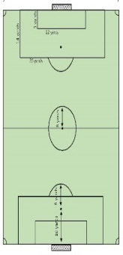
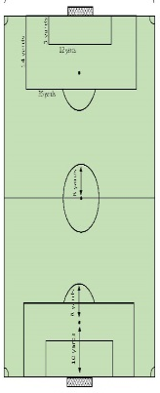
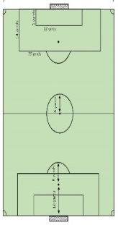
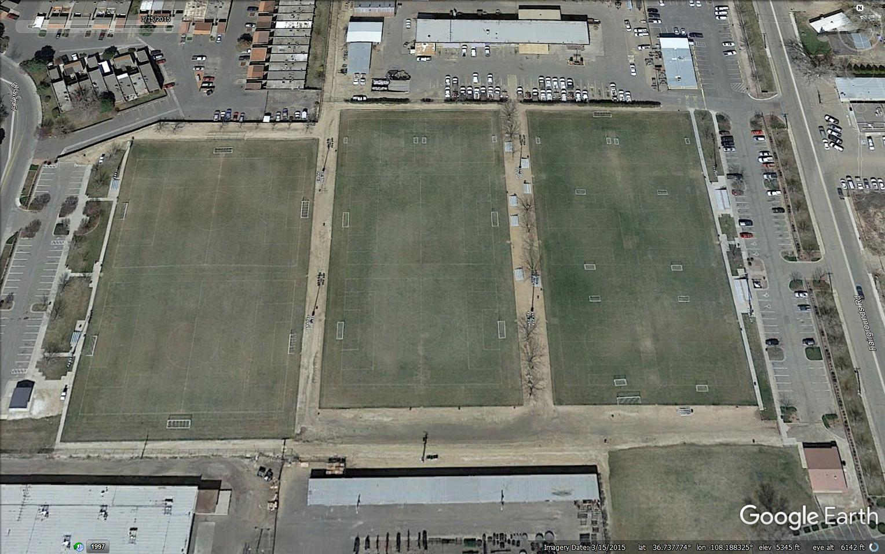
FIELD #4
FIELD #3
Warm-up area
FIELD #6
FIELD #2
Food vendors, merchandise, restrooms, U8 Field, Pana Cage, and tournament HQ.
All spectators must stay outside the fences. No spectators allowed on the fields.
FIELD #5
FIELD #1

PARKING MAP

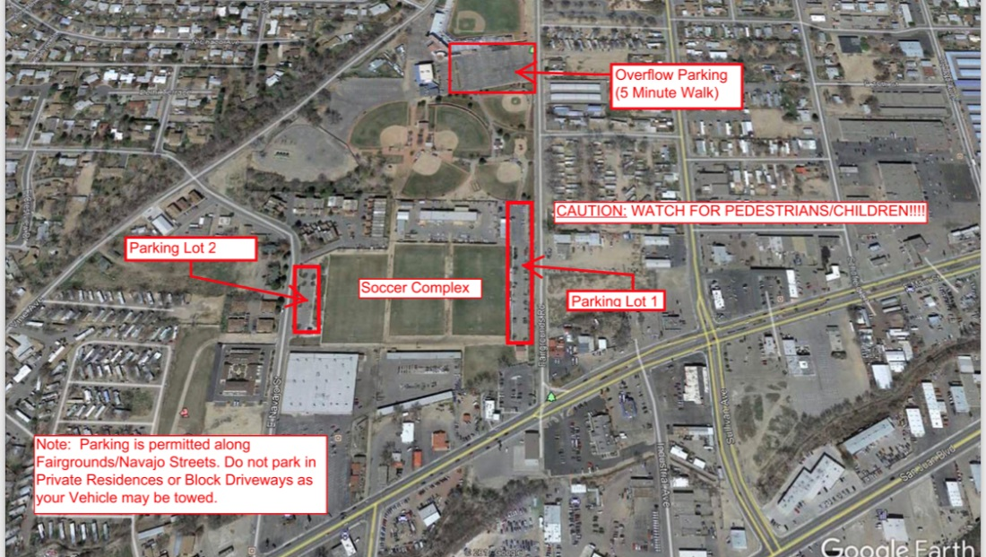
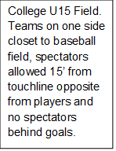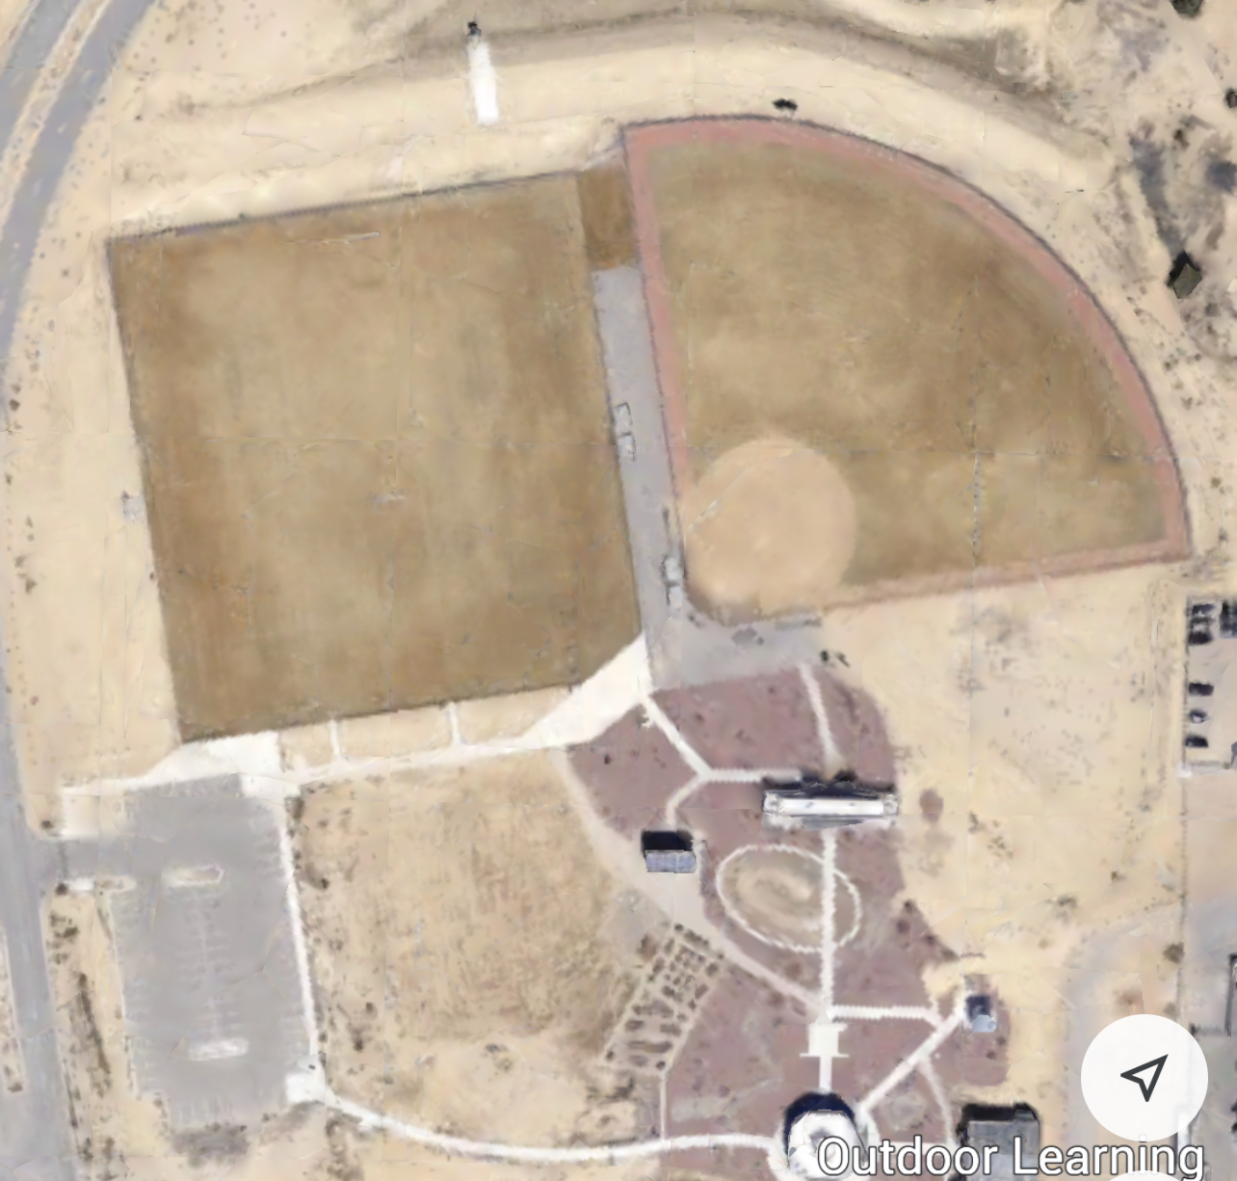
College U12 Field will be on the baseball field. Teams will sit by the fence and spectators can stay 15’ from touchline and not behind goals

Directions from Soccer Complex:
Head south on Fairgrounds or Navajo Roads, turn right on Main Street heading West, take right on Butler heading North, go to the end of Butler and make a right on Pinion Hills Blvd heading East, take a right on Education Drive at the flagpoles. Soccer field is on the left.

Fine Designs

Fine Designs is our official Merchandise partner!!
Stop by and say hello and browse some of their awesome inventory!!

Concessions

Food trucks available by Tournament Tent:
The Salty Chef
Frost Joy

